

**JACKWAGON SMOKED RIBS & BBQ ONCE A MONTH, CHECK WEBPAGE FOR WHEN WE WILL BE SMOKING NEXT!!!**

DINNERS

**1lb. Ribeye** *Fresh Cut & Grilled To Order, Served With 1 Side, House Salad,& Texas Toast* **$18.99**

**1/2 lb.Ribeye** *Fresh Cut & Grilled To Order, Served With 1 Side, House Salad,& Texas Toast* **$10.99**

**1lb.Smoked Pork Chop** *Butterfly boneless, Served With 2 Sides, & Texas Toast* **$13.99**

**1/2lb.Smoked Pork Chop** *Butterfly boneless, Served With 2 Sides, & Texas Toast* **$10.99**

**Southern Catfish Plate** *½ lb of Fish battered in Our Signature Louisiana Style Breading “spice not heat”,*

*Served With Hush Puppies, Slaw & Fries (****All You Can Eat Add $2.99****)*  **$8.99**

**Salisbury Steak** *Served With Brown Mushroom Gravy 2 Sides & Texas Toast one slice***$7.99** *two* **$9.99**

**Mesquite Chicken Fillet** *Hot Off the Grill Served With 2 Sides & Texas Toast* **$7.99**

**Country Fried Steak** *Served With a Generous Helping of White Pepper Gravy, 2 Sides & Biscuit* **$7.69**

**3 Chicken Strips** *Served Regular or In a Mild Buffalo Sauce, With 1 Side, White Pepper*

*Gravy & Biscuit* **$7.69**

**Chop Steak** *Seasoned And Charbroiled to Perfection With Grilled Onions and 1 Side one slice***$7.69** *two* **$9.69**

**Sides**

French Fries          $1.65  
Onion Rings  $1.65  
Fried Okra           $1.65  
Cottage Cheese    $1.65  
Potato Salad           $1.65   Applesauce            $1.65    Side Salad            $1.65 Country potatoes $1.65 Slaw $1.65

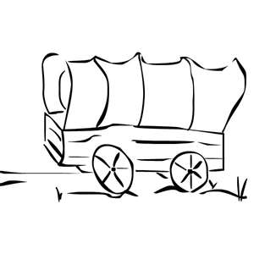

Add 5 Cajun Grilled

Shrimp to Any Meal

$3.25

Grilled Onions

$1.55